# Syria Economic Monitor – Survey Analysis

## Humanitarian assistance

Communities strongly affected by the earthquake (in Northwest Syria) were more likely to receive humanitarian assistance than communities that were less affected (in Northeast Syria), both before and after the earthquake. Approximately 80% of the communities that were strongly affected by the earthquake were already receiving humanitarian assistance prior to the earthquake. As Figure 1 shows, by March 2023 access to humanitarian aid increased for the resident population but remained comparable to pre-earthquake levels for the internally displaced population (IDPs). The data suggests that increases for residents were short-lived; by April 2023 access to aid was comparable to pre-earthquake levels for both populations. There is a notable change in composition of aid post-earthquake: cash and food vouchers increase significantly immediately after the earthquake as shown in Figures 2 and 3. By April, cash assistance had returned to pre-earthquake level but provision of food vouchers remained higher than it was in the pre-earthquake period. For residents, these changes contribute to an overall increase in humanitarian assistance. For IDPs, increases in cash and food were offset by decreases in direct food aid and water and sanitation services.

## Access to services

Access to community electricity networks was substantially lower for communities in NWS strongly affected by the earthquake than communities that were less affected (in NES). Immediately after the earthquake, access to electricity increases substantially in the strongly affected communities but does not change in communities lightly or moderately affected, as shown in Figure 4. These new connections translate directly into improved access for households: in strongly affected communities, the proportion of communities reporting less than 8 hours of electricity per day drops from two-thirds (pre-earthquake) to less than half (post-earthquake). Access to food markets, health services and education is not noticeably affected by the earthquake. Communities strongly affected by the earthquake had more access to food markets and health services prior to the earthquake and there is no significant change in trend observed after the earthquake. Nearly all communities in the sample had access to education services prior to the earthquake and there is no noticeable effect of the earthquake.

## Priority Needs & Coping Strategies

In the post-earthquake period, the primary needs for the IDP population are food, shelter, and livelihood support. For residents, the top priority needs are food, livelihoods support and water and sanitation services. In communities strongly affected by the earthquake, food and shelter needs are particularly pronounced; these needs were already higher in the pre-earthquake period and the gap increases in the period after the earthquake, as shown in Figures 5 and 6. One-third of the strongly affected communities report that food is the top priority need for IDPs, compared to only about 1 in 10 of the less-affected communities. Residents in communities strongly affected by the earthquake also reported a significant increase in food needs directly after the earthquake. By April, residents’ demand for food had dropped, which is consistent with the significant increase in food aid observed in the same communities. Demand for shelter increased for residents and IDPs immediately after the earthquake; April data suggests that residents shelter needs are increasingly being met whereas shelter remains an important priority for IDPs. In terms of coping strategies, IDPs and residents both increases sales of household items and productive assets in communities strongly affected by the earthquake. Somewhat surprisingly, there are substantial decreases in reports of sending children to work or to early marriage for both residents and IDPs, possibly due to humanitarian interventions.

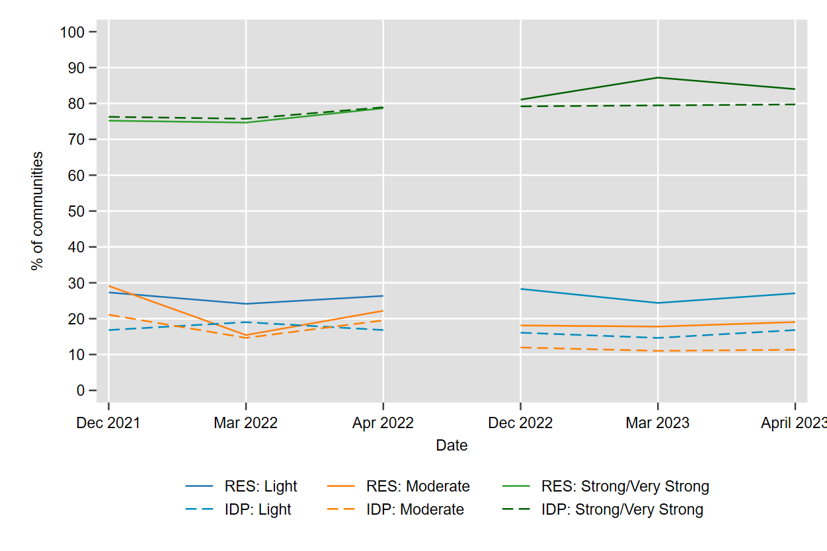

Figure : Communities in which residents had access to humanitarian assistance

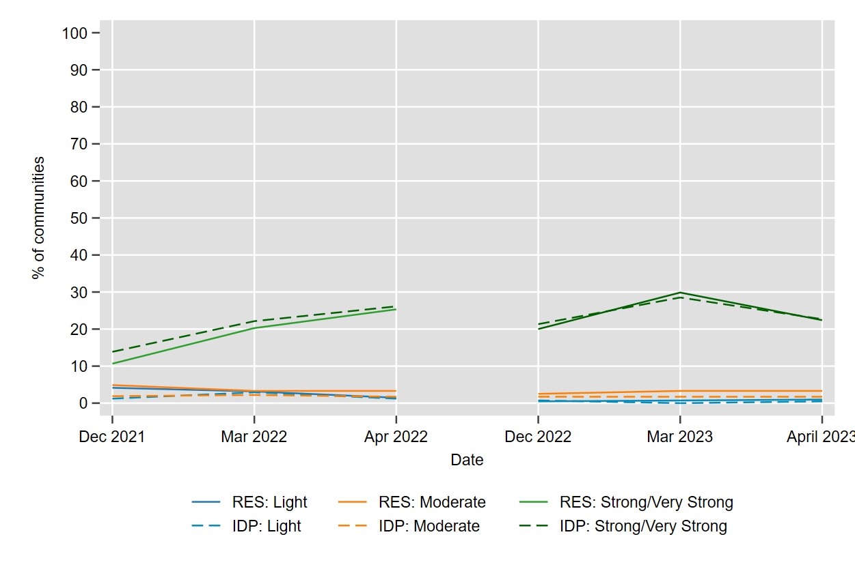

Figure : Communities that received humanitarian assistance in the form of cash

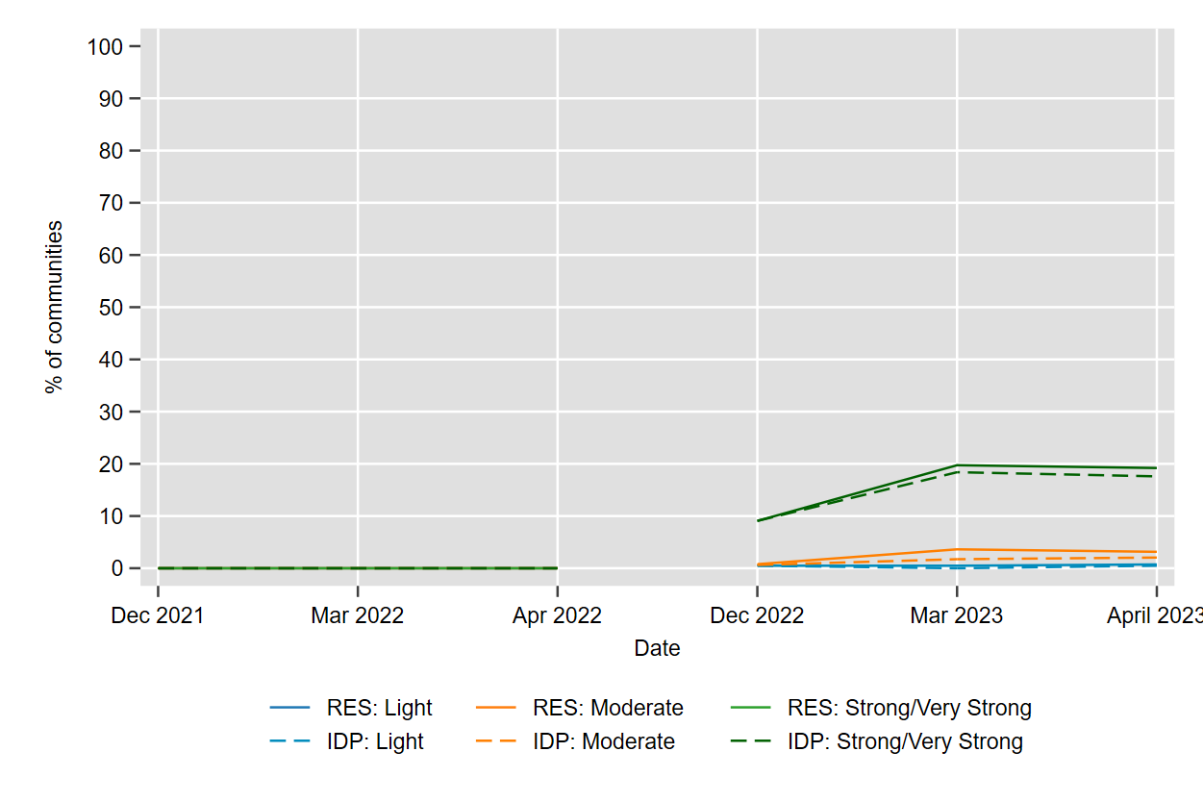

Figure 3: Communities that received humanitarian assistance in the form of food vouchers

Figure 4: Electricity access. Panel A: main source of electricity. Panel B: communities with less than 8 hours of electricity per day.

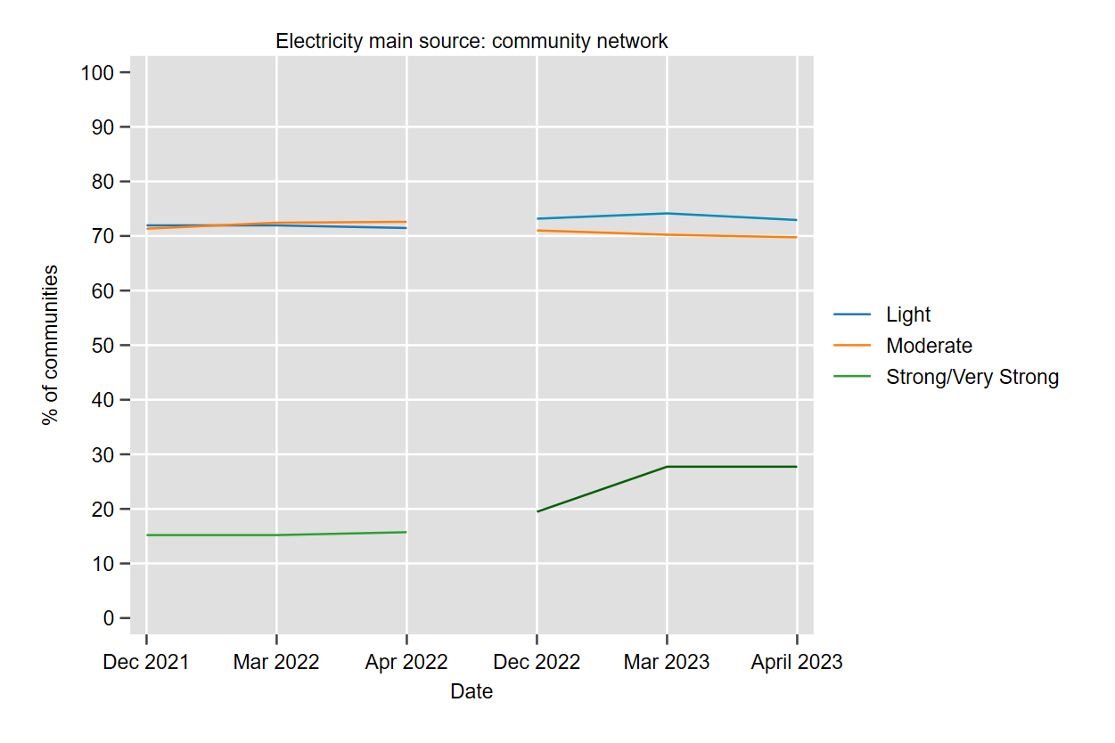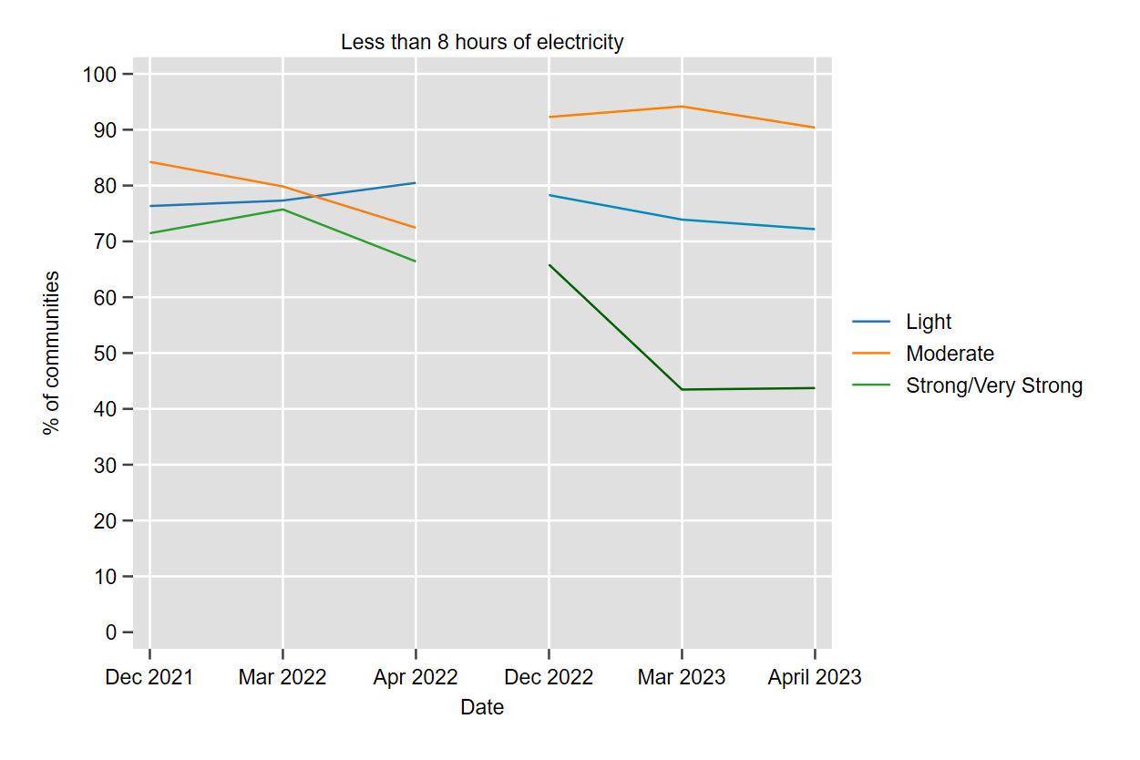

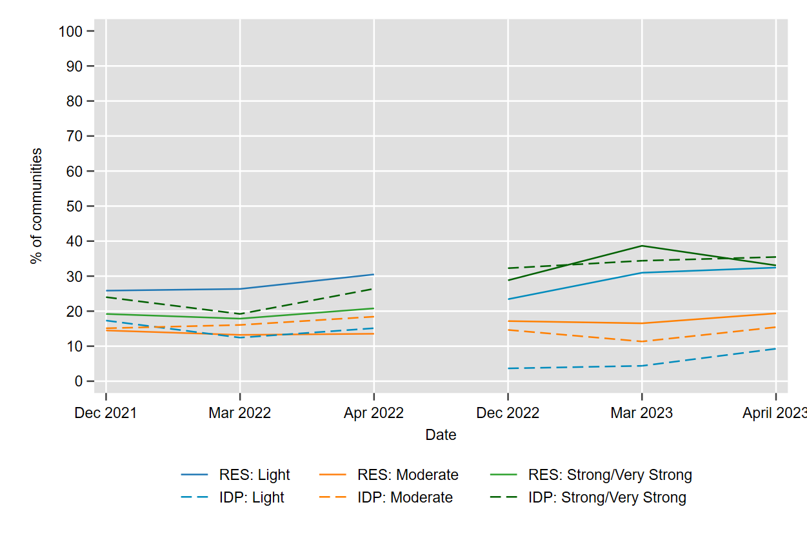

Figure 5: Communities in which food is the top priority need

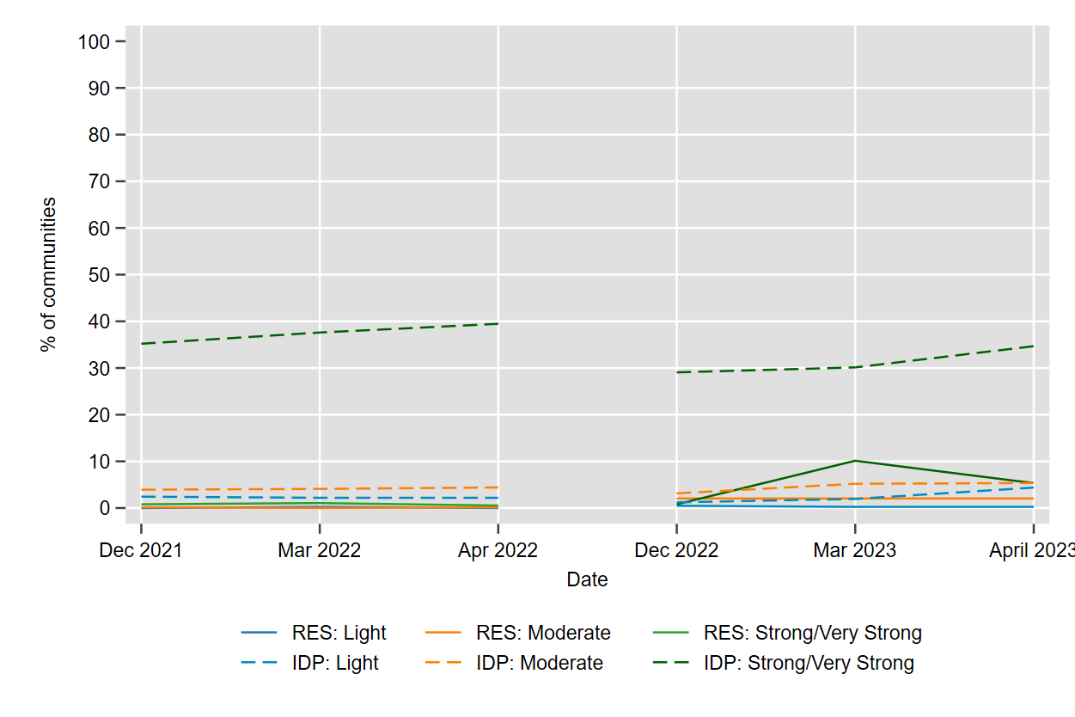

Figure 6: Communities in which the top priority need is shelter

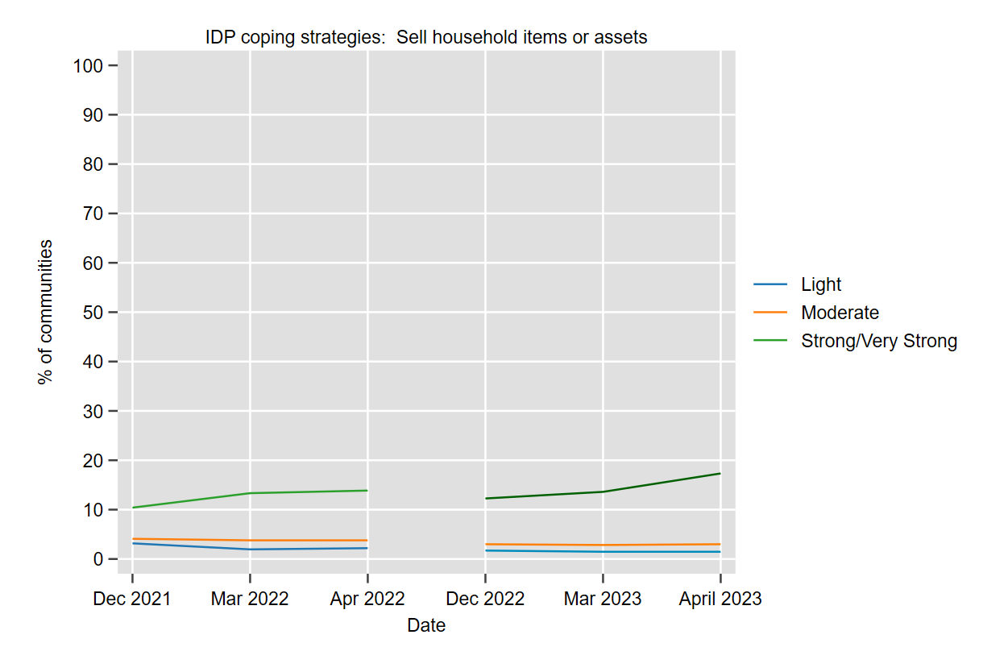 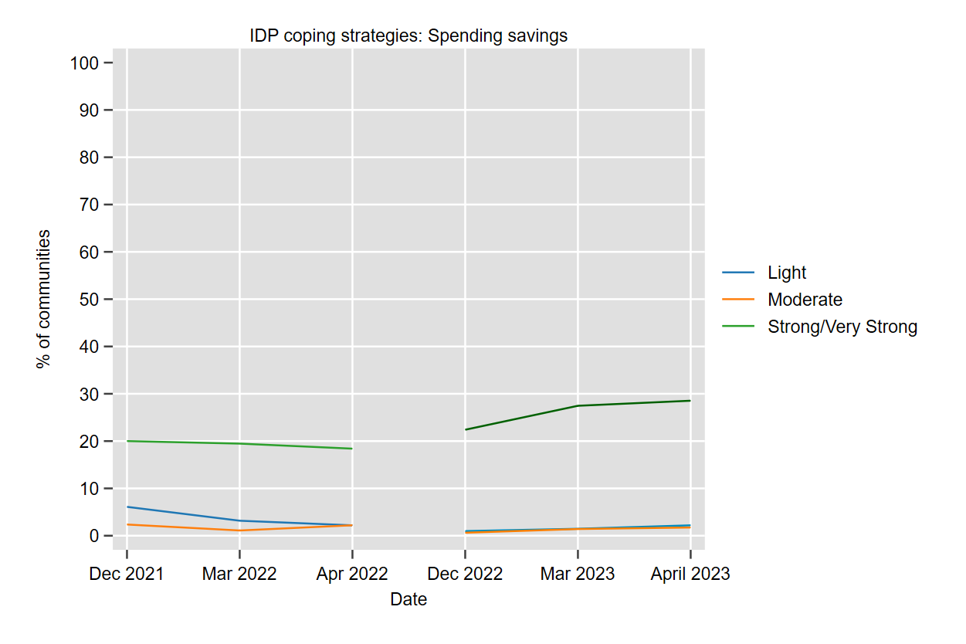

Figure 7: Coping strategies for internally displaced persons. Panel A: sales of household assets. Panel B: spending savings.

# Possible graphs to add

